Name(s): _____________________________________________________________
Challenge
In Objects and Functions Tutorial (http://aka.ms/ObjectsTutorial), you discovered many new functions for the turtle object. In this activity, you will discover and describe functions related to the game object. The game object has many functions that are helpful when building games in TouchDevelop.
Directions
Follow the steps below to explore functions of the game object.
- Open https://www.touchdevelop.com/app. Make sure you are signed in to TouchDevelop.
- Select Create Script, select blank game, and provide a fun name for your script.
- Your blank game isn’t really blank. The code for a very simple game is included in the starting template. Take a minute to examine the code, and then select run to see what it does.
- Return to editing the script. Write the names of four functions that are associated with the game object in the script you see in the first column of the table below in question 1.
- For each function you identified, select the line that the function is on. Your cursor should be at the end of the line (next to the function). Select help… as shown in the diagram.
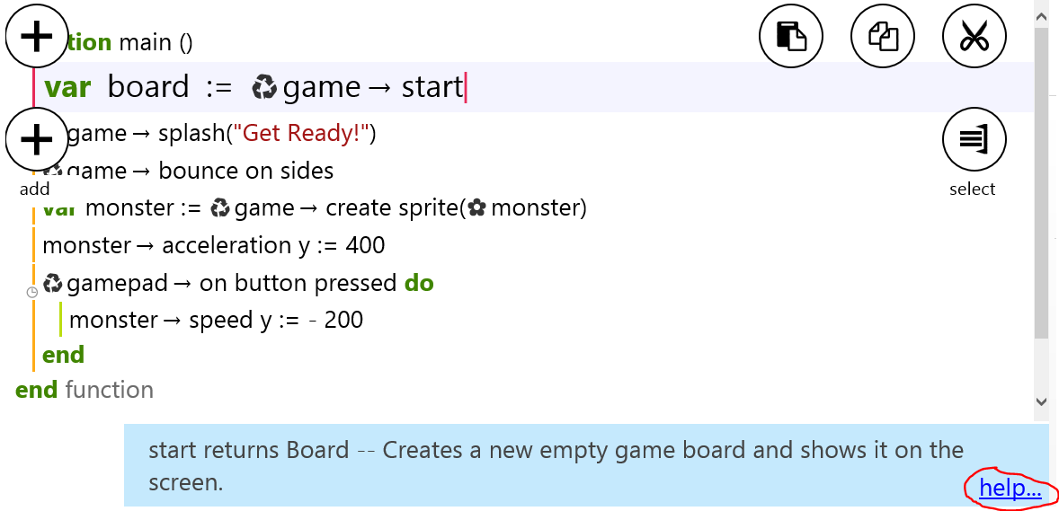
Use the resulting help page to learn about what each function does and the parameters it accepts (if any).
- Record the information in the table below.
Function name | Description of what it does | Parameters

- Write three questions that you would like to ask based on this activity.

