Name(s): ________________________________________________________________
Computers are used to solve a variety of problems. One type of problem that can be hard for computers is called optimization problems. Optimization problems involve finding the best solution from all possible solutions. Figuring out class schedules for students so that there are the fewest conflicts possible, the best use of class space, and teacher availability is an example. Planning the best route for delivering newspapers or planning bus stop locations are also optimization problem.
These are hard problems because there are just too many possible solutions and it’s hard to know which is really the best or most optimal. The only way to decide what is best is to try every possible solution. As the size of the problem set increases, the time it takes to test all of the possible solutions grows exponentially. The schedule solution for 10 students with two teachers and three classrooms is easier than 500 students with 30 teachers and 17 classrooms.
Challenge
Color the following images with the fewest number of colors so that no two bordering sections have the same color.
 | 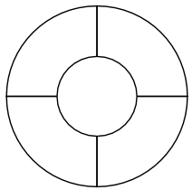
Easy | Harder

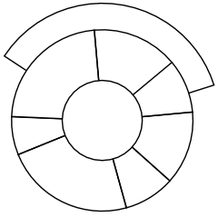
Even a bit harder

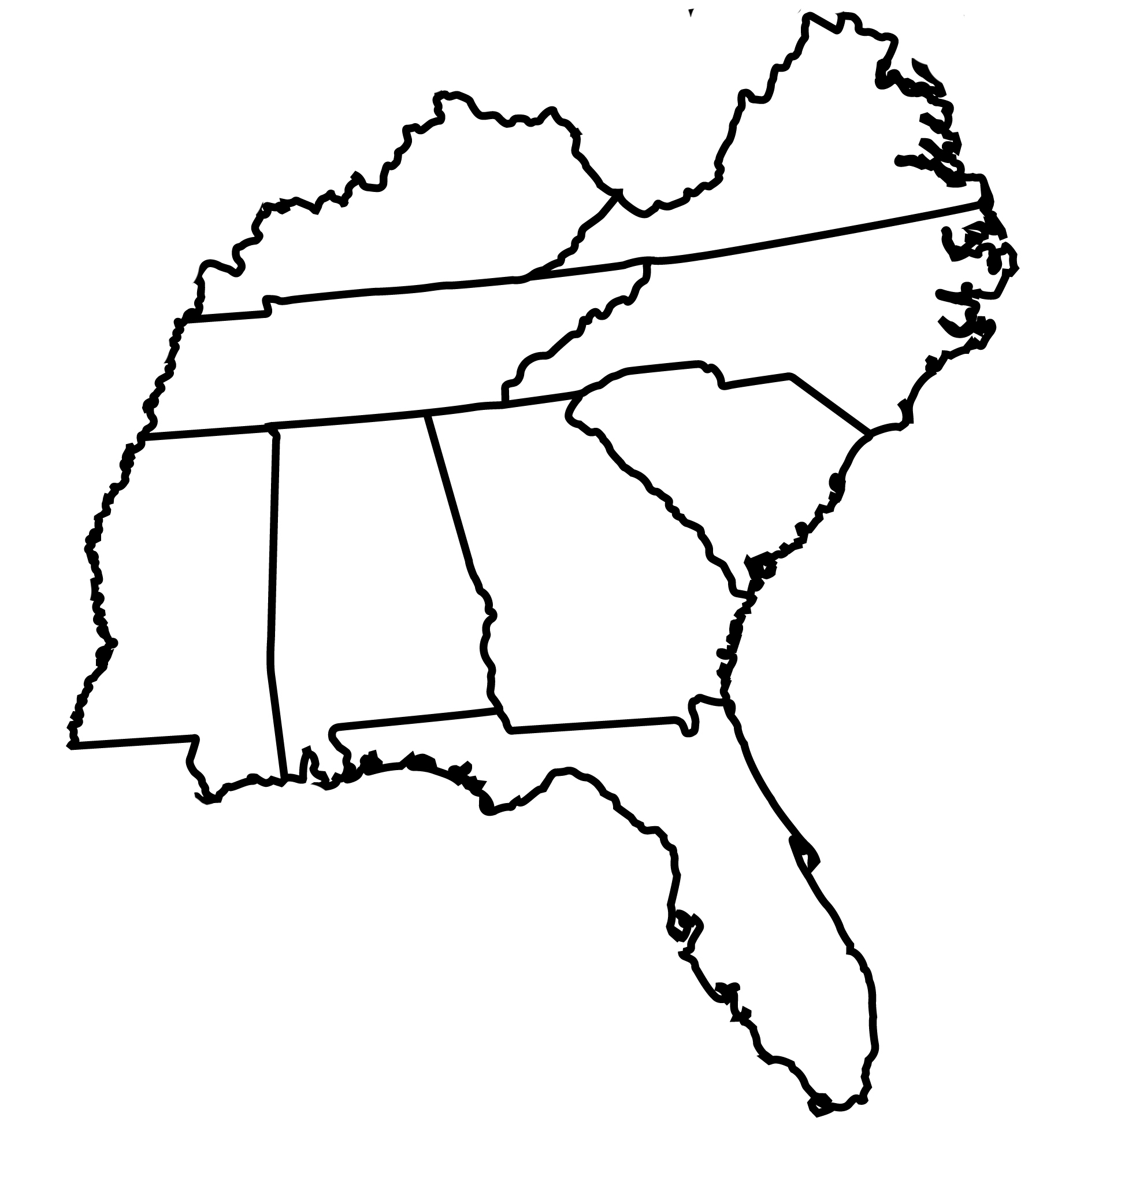
Hardest

