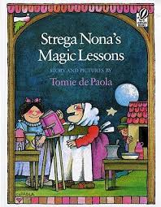
Name:

STREGA NONA’S MAGIC LESSONS

Name the different jobs you observed.

Was Strega Nona paid for the work she does?
Is Big Anthony paid for his work?
Who pays them?

Compare how Bambolona and Big Anthony work.

Who is a responsible worker?

What are Big Anthony’s responsibilities?

What does he do that is not responsible?

Do you think Big Anthony will make the same mistakes again?

What does it mean to be responsible?

What are some of your responsibilities?

What are the benefits of being responsible?

What are the problems with being irresponsible?

Is it possible to get paid for every responsibility? Why or why not?

What are some ways people act responsibly, but they are not paid?

