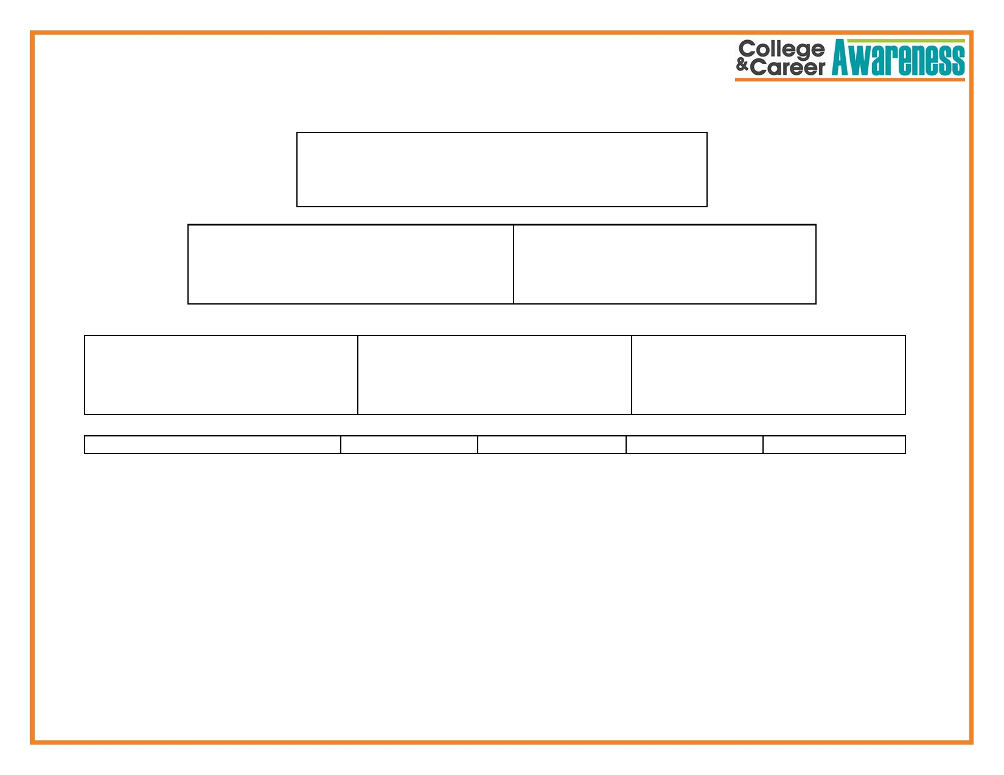
CTE Pathway:_____________________

Foundational Courses : Language Arts Mathematics Life/Physical Science Social Studies FA/CTE/PE/Electives

Please select a CTE Pathway Chart your teacher has provided and decide as a group courses a student must take to complete a CTE Pathway. Add the courses to the boxes to reflect the courses necessary for a student to complete the Pathway.

Add more boxes to the pyramid if it is needed.

