Music Video Assignment
Openshot

Perquisites:
- Video footage that can be used in a music video. At least 5 minutes worth of various students doing crazy stuff!
- The free program Openshot must be installed
- MP3 files for several different popular songs that can be imported in

Startup:
- Open the program Openshot.
- Press the “+” button to import video. Find the video files as directed by your instructor. 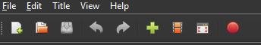
- Now you will see all the video files displayed.
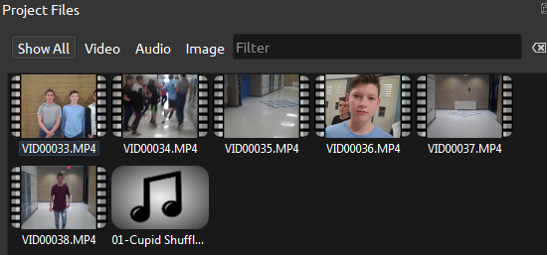
- Now import a song by clicking on the “+” button again and pulling in a song from the provided file.
- Drag the music file into Track 0, aligning at the beginning of your timeline.
- Drag in one of your video files to begin.

Watch the video to learn how to cut your music video.
https://www.screencast.com/t/pnSmZO88

Required Elements:

Video is AT LEAST 45 seconds long
Sound has been removed from the original video footage—only the music can be heard
Video has been cut in multiple locations
Video has a song running in the background
Video is sped up or slowed down the video in at least one place
Fade is used at the beginning or end of at least one clip
Transitions between videos to fade on in to another at least once
The song is trimmed to the length of the video
The song fades at the end
There is a title page with your name and period (either at the beginning or end)
The file has been exported as an .MP4 file

