DAY 1: Colors of the Computer
Write the numbers for each color in each bubble or below the bubble.

Red
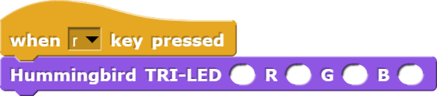
Red
Green
Blue

Green
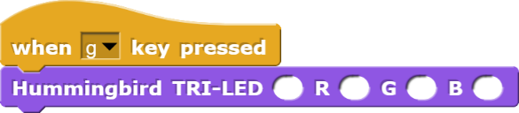
Red
Green
Blue

Blue
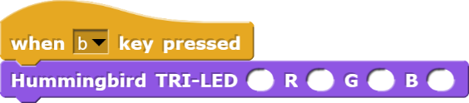
Red
Green
Blue

Black
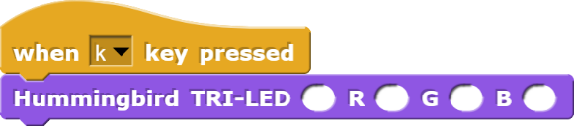
Red
Green
Blue

White
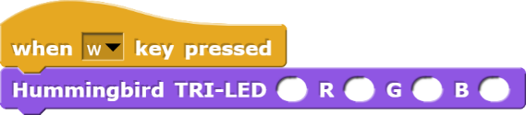
Red
Green
Blue

Cyan
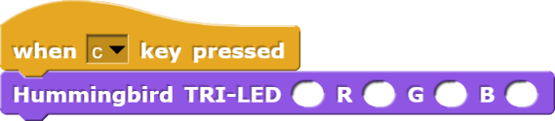
Red
Green
Blue

Magenta
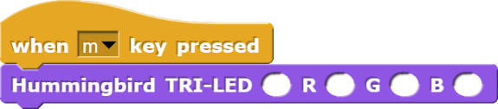
Red
Green
Blue

Yellow
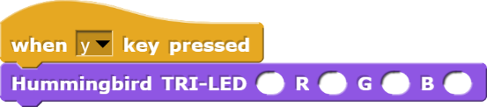
Red
Green
Blue

DAY 2: Solar Light Code
Write the numbers in the space provided for each block.

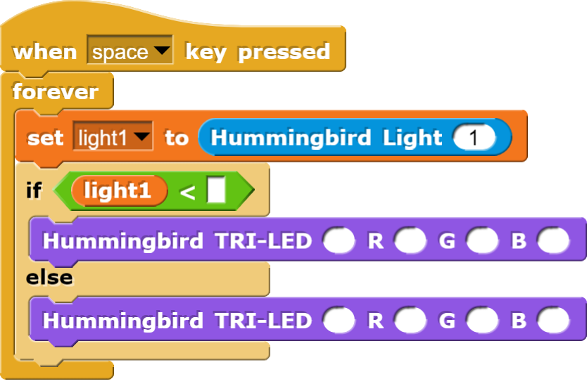
Temperature
First Block
Red
Green
Blue
Second Block
Red
Green
Blue

DAY 3: Temperature Sensor (e.g. refrigeration)
Write the numbers in the bubble for each block.
(Optional) Color the blocks the correct color.

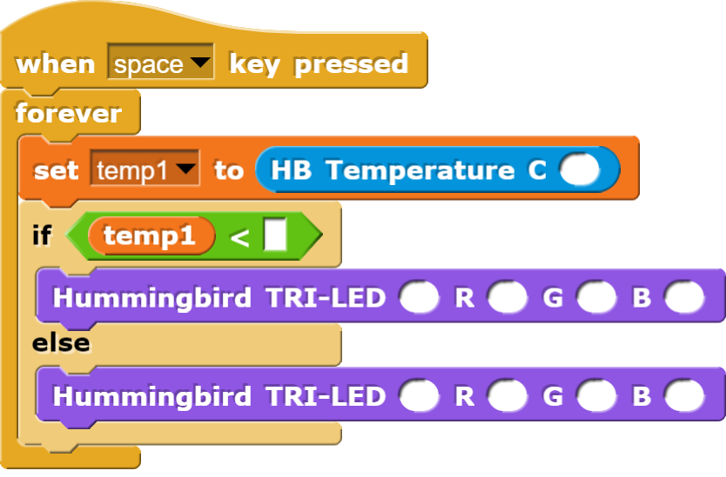
Temperature
First Block
Red
Green
Blue
Second Block
Red
Green
Blue

Optional Activity for Day 1,2, or3: Blinking Light

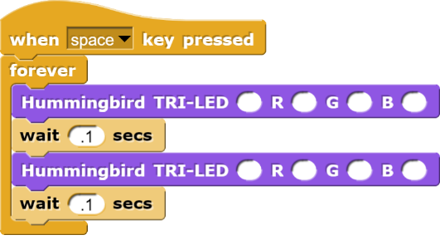
First Block
Red
Green
Blue
Second Block
Red
Green
Blue

Day 4: Servo Motors Light Gauge
Reset
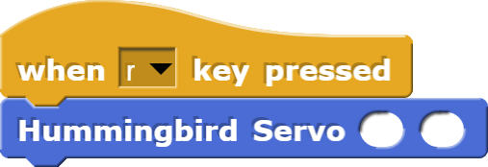
First Circle
Second Circle

Set
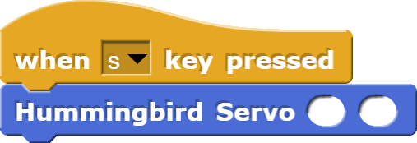
First Circle
Second Circle

Gauge
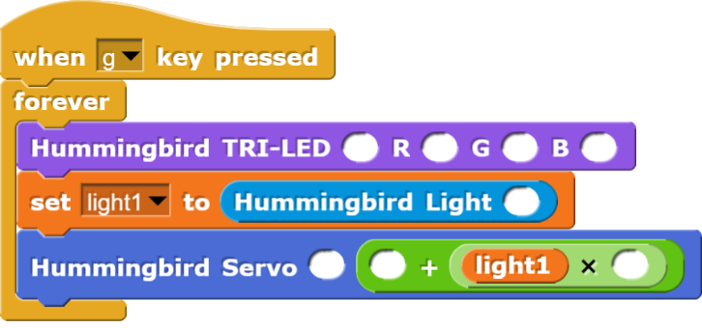

Day 5: Servo Motors2 Garbage Truck Claws
Street
First Circle
Second Circle

Truck 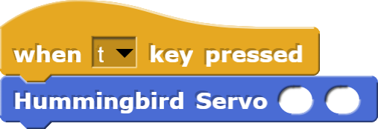
First Circle
Second Circle

Open
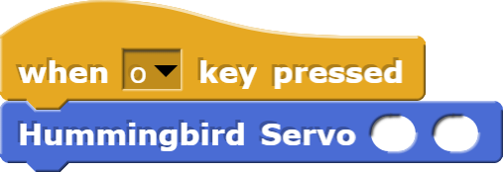
First Circle
Second Circle

Close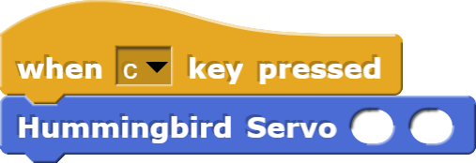
First Circle
Second Circle

Garbage Pickup
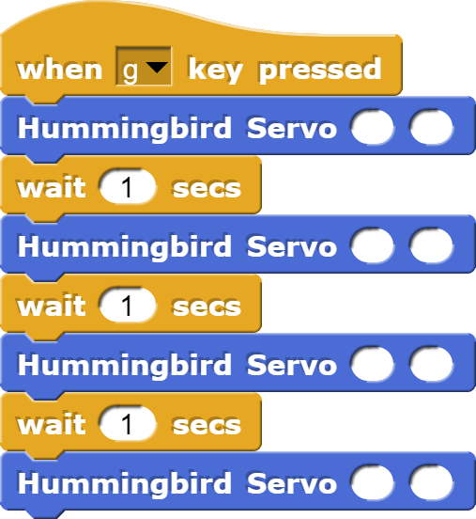
First Circle
Second Circle
Third Circle
Fourth Circle
Fifth Circle
Sixth Circle
Seventh Circle
Eighth Circle

Day 6: Vehicular Control

