Name:

Holland Codes
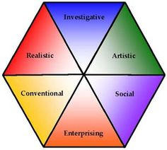

Directions: in the space provided, list 3 careers that go with each of the following Holland Codes.

- Realistic:

- Investigative:

- Artistic:

- Social:

- Enterprising

- Conventional:

Type one word to describe each of the following Holland Codes:

- Realistic:

- Investigative:

- Artistic:

- Social:

- Enterprising

- Conventional:

