Digital literacy
RADIO AD
USING AUDACITY

You will be creating a 30-second radio commercial advertising a product from the Industrial Revolution. Assume that you are living during that time period.
- Listen to some existing radio commercials. https://www.babble-on-recording.com/samples/
2. List at least 3 characteristics that make a commercial successful:
A.
B.
C.
3. Read the following scripts.
McDonalds Radio Ad 2015 Script
Call yourself a bargain hunter? Compared to Beth, you are but last season’s shop-soiled clutch bag with 5 percent off. Because when you’re tucked up in bed dreaming of a half-price halter-neck, Beth is camped outside her local designer outlet, waiting for the shutters to roll up, living your dream. And while she is, she knows McDonald’s are there with over 500 restaurants open 24 hours. If you’re awake, we’re awake.
Army Radio Ad 2015 Script
MVO Sometimes people put men in one box and women in another. Men are strong and decisive. Women are soft and emotional. Just because I wear lipstick and mascara, why can’t I be the one in charge? I suppose that’s why I joined the Ar… [At this point the man’s voice morphs into a woman’s voice]
FVO1 ...Army.
Because here I’m seen for what I really am. A troop commander.
FVO2 There’s more than one way to be the best. Search Army jobs.

McDonalds’s 2017
Driver: The roads have emptied. Only us left. Kids sleeping in back. Cat’s eyes shine bright. White lines roll by. The rhythm of the street lights. Radio hums quietly. Rain starts. Hypnotic wipers. Pull in. Hot latte and apple pie. Ease back into the darkness.
VO: Over 600 McDonald’s open 24 hours. We are awake

4. Create a script to advertise a product from the Industrial Revolution (Steam Engine, Cotton Gin, Steamboat, Telegraph, Sewing Machine, Telephone, Transatlantic Cable, Phonograph, Electric Motor, Diesel Engine, Airplane, Model T Ford)
https://www.thoughtco.com/industrial-revolution-inventors-chart-4059637
http://www.brighthubeducation.com/history-homework-help/91805-important-inventions-of-the-industrial-revolution/
My Product:
Slogan:
My Script (words for your radio commercial):

**Make sure your slogan is included at the very end of your radio ad
5. Find appropriate music for the background. Use soundzabound. http://www.soundzabound.com/mymusic/utah
6. Once you find a song to use in your commercial, download it, and save it to your files. Make sure the duration is no more than 30 seconds.
To listen, click on the play button at the far left.
To download, click on the “Download” button at the far right in soundzabound.

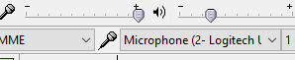
7. Open Audacity, plug in the microphone, and record your script. (Make sure you have selected the correct recording device)

8. To record, click on the button with the red, circle. 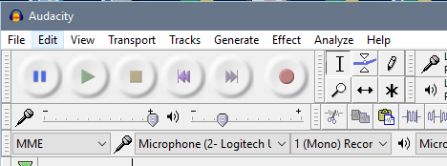
9. Once you have recorded the script, export it as an MP3. Name it “Script.” Save it to your files. (Select File from the pull-down menu, then Export Audio)
10. In Audacity, select File>New.
11. Drag in your music file and your audio recording.
12. Make adjustments to volume, length, etc. until you are satisfied with your results. Remember commercial should be no longer than 30 seconds.
13. When you are done, export it as an MP3. Save it to your files as your last name, first initial of your first name, then ircommercial.
14. Drop it to Mrs. Blauer.

