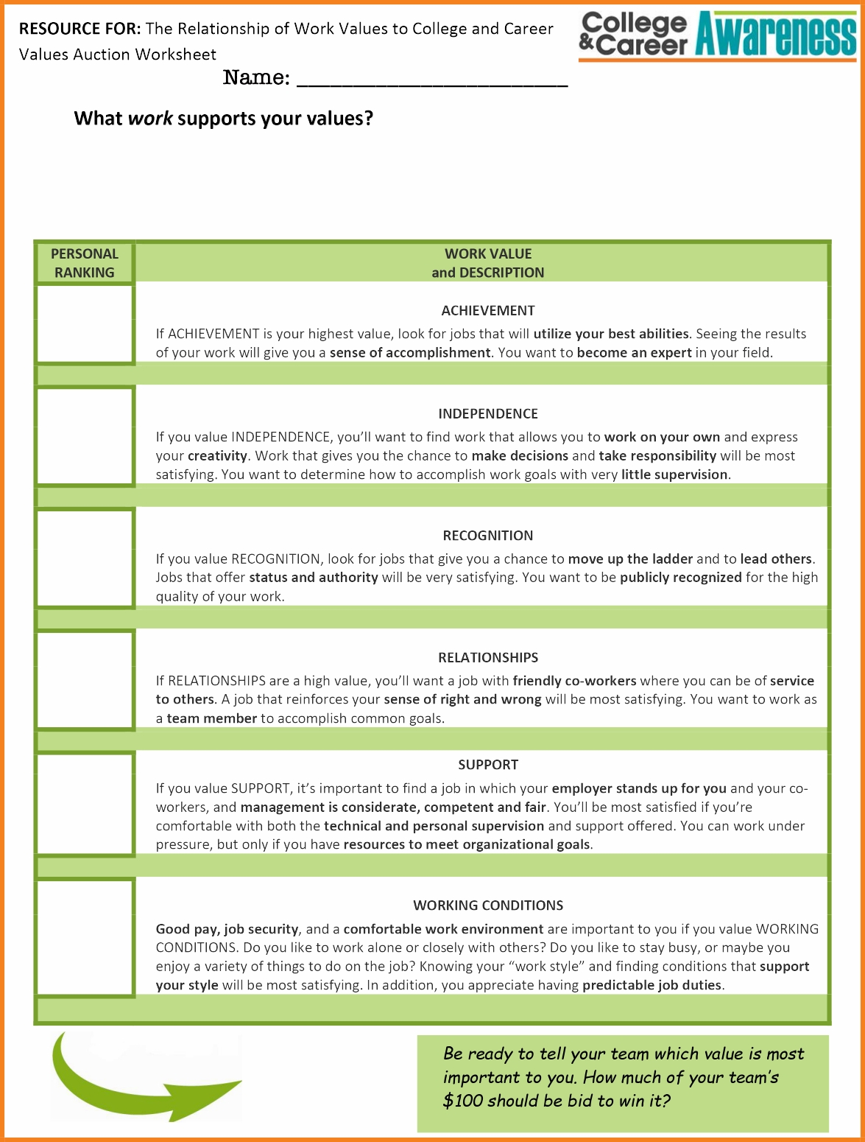

Name:

Rank the following: (1 being the most important, 6 being the least important)

_____ Achievement

_____ Independence

_____ Recognition

_____ Relationships

_____Support

_____ Working Conditions